# Rashed Mahamud Roman

# 22301628

# CSE 321(Sec: 06)

# Operating Systems

# Lab Assignment 1

### 

### **Task-1:**

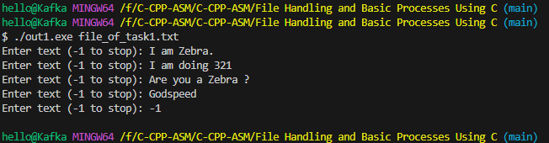

**Task-2:**

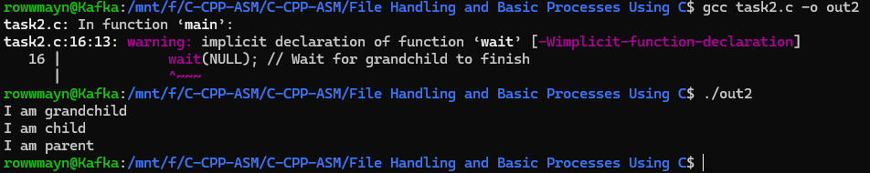

### 

### **Task-3:**

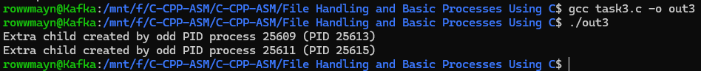

### **Task-4:**

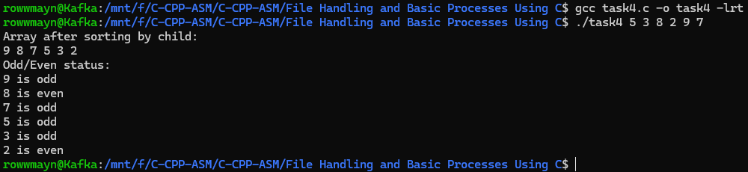

**Task -5:**

